**METHODS**

**I. Reconstruction of the Tumorigenic Intracellular Signaling Network With Multi-Omics Data**

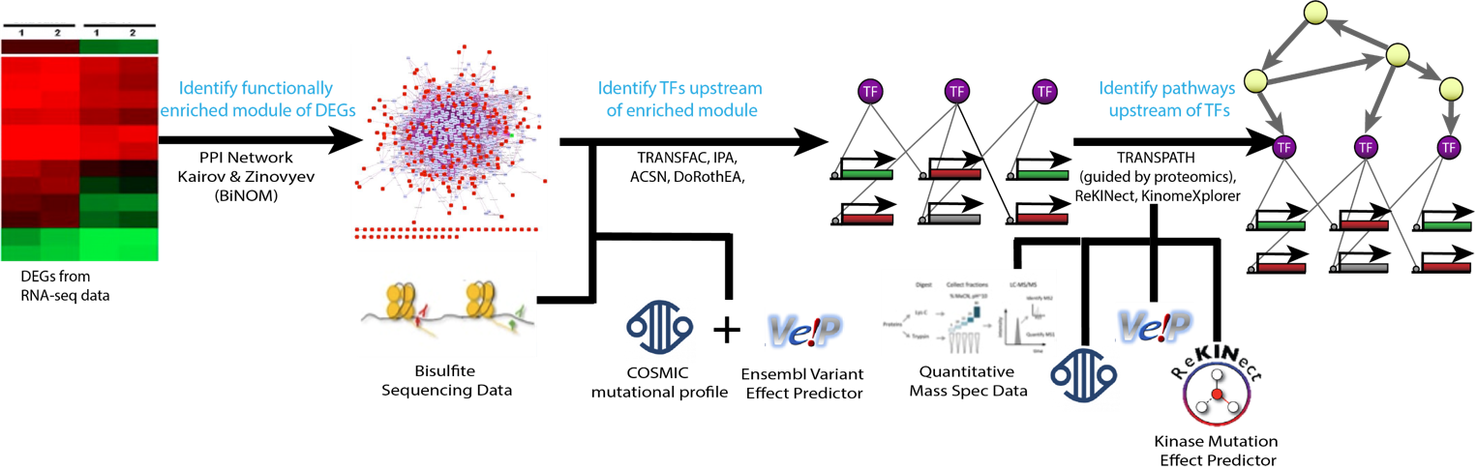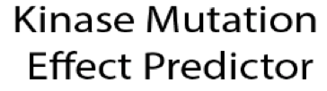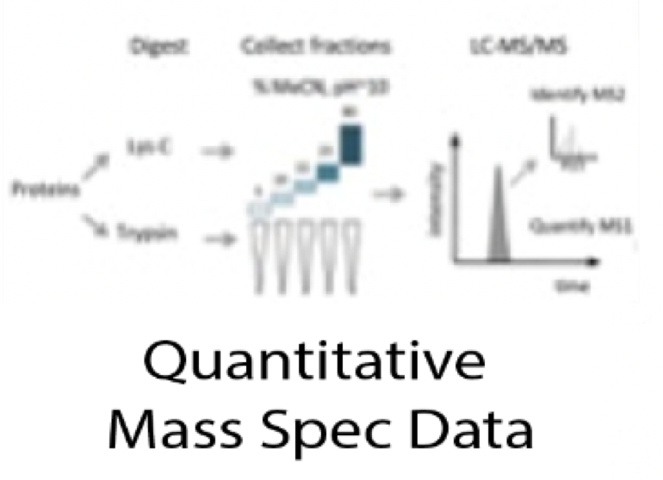

**Figure 1.** Pipeline for the reconstruction of the CL TNBC intracellular signaling network using multi-omics data.

*Data Collection*

Pair-wise RNA-seq data for the CL TNBC cell line MDA-MB-231 and the normal breast cell line MCF10A was taken from [[29458327](https://www.ncbi.nlm.nih.gov/pubmed/29458327)], which is deposited at Gene Expression Omnibus under the accession number GSE96860. Each cell line has two biological and two technical replicates. Bisulfite data for MDA-MB-231 was obtained from [24176112] deposited in Gene Expression Omnibus (GEO) accession number GSE42944. SNV and CNV profiles have been obtained for MDA-MB-231 from Catalogue of Somatic Mutations in Cancer (COSMIC) Cell Lines Project under sample ID COSS905960 [30371878]. Label free quantitative mass spectrometry for MDA-MB-231 was obtained from [25892236], deposited in proteomicsDB under the accession number PRDB004167.

*RNA-seq Data Processing and Differential Expression*

The raw RNA-seq files were sent to Psomagen for a differential expression analysis. The Trimmomatic program was used to drop adaptor sequences and bases with base quality lower than three from the ends, and the sliding window method was used to remove bases that do not qualify for window size 4 and mean quality 15. Reads with length shorter than 36bp were also dropped to produce trimmed data. The trimmed reads were mapped to hg19 using HISAT2, a program that handles spliced reads through Bowtie2 aligner, and known transcripts were assembled with StringTie. If more than one read count for the eight samples was zero, the gene was excluded from the analysis. This includes the removal of all genes with copy number loss as denoted by COSMIC CNV data. Reads were normalized with Relative Log Expression normalization and differential expression was calculated using a Wald test with a negative binomial distribution in the DESeq2 R package.

*Ranking Differentially Expressed Genes*

Differentially expressed genes (DEGs) were filtered for a False Discovery Rate (FDR) less than 0.05, and a P-value less than 0.001. Two different methods were used to rank the DEGs. First, by ascending p-value from the differential expression analysis. Second, a pseudo-z-score adapted from Ruthi et al. was computed for each gene and ranked by its descending absolute value [25195578]. The pseudo-z-score of the expression of node $i$ is:

$$Z_{i}= \frac{e_{i,N}-μ_{i,N}}{σ_{i,N}}$$

Where $e_{i,N}$ is the average expression of gene $i$ in the cancerous cell line, $μ_{i,N}$ is the average expression of gene $i$ in the normal cell line, and $σ_{i,N}$ is the standard deviation of the 4 replicates of the expression of gene $i$ from the normal cell line. This score reflects the cancerous expression level of a gene compared to the distribution of expression in the normal samples, and is related to the probability that the expression level in the tumor is from the same distribution as is in the normal tissue.

*Identification of Functionally Related Differentially Expressed Genes*

While classical network construction methods use the first *n* ranked differentially expressed genes selected by a statistical approach as the first layer of the network, this pipeline uses functionally related genes as the first network layer [23055628]. This method developed by Kairov et al. allows for the consideration of biological properties when selecting which genes to include in the network as opposed to a statistical cutoff, therefore capturing functional relationships that classical methods cannot. Thus, these functionally related differentially expressed genes (FunDEGs) form a functional core between DEGs, but are not necessarily the most differentially expressed. The method stems from percolation in graph theory, where one can estimate the expected size of the largest connected component given a graph and $k$ randomly selected nodes. For some $k_{crit}$ number of ranked nodes, most of them are included in the largest connected component (LCC). Thus, if the first $k$ ranked nodes ($k≪ k_{crit}$) form a largest connected component larger than expected by random, their connections are non-random, and they form a functionally related core.

The method is implemented in the BiNOM Cytoscape 2.8.3 plugin with the Human Protein Reference Database (HPRD) as the interaction graph and works as follows [23453054]. First, *k* top-ranked DEGs are mapped into the HPRD. Assume $k'$ ($k^{'}≤k$) of these DEGs are found in the HPRD. The size of the largest connected component (LCC) formed by these $k'$ genes is denoted $C\left(k^{'}\right).$ Then, $k'$ genes are randomly sampled from the HPRD, preserving the connectivity distribution of the $k'$ ranked DEGs, and the size of the LCC, $R(k^{'})$, is recorded. This step is repeated 10,000 times and the mean size of the LCCs ($Mean(R\left(k^{'}\right)$) is calculated. The percolation score, $S$, is computed for $k'$:

$$S=\frac{C\left(k^{'}\right)-Mean(R\left(k^{'}\right))}{k'}$$

This process is repeated for values of $k$ from 50 to 1000 in increments of 50. The optimal $k$ ($k_{opt}$) is chosen as the smallest $k$ such that $S$ decreases as $k$ increases for ${k> k}_{opt}$ [23055628]. This analysis was run separately on the DEGs ranked by p-value and the DEGs ranked by pseudo z-score. Housekeeping genes, except for VIM because it is a marker of EMT, were filtered from the functionally related core and the resultant LCC was selected as the set of First Order FunDEGs [19534766].

After identifying First Order FunDEGs, BiNOM was used to identify Second Order FunDEGs. This step identifies nodes in the HPRD that are not included in the First Order FunDEGs, but have known interactions with those genes. Thus, the genes in the Second Order FunDEGs need not be differentially expressed, but are functionally related to those that are, and could play important roles in tumorigenesis. Housekeeping genes and genes that are not expressed in MDA-MB-231 were removed from this set of genes and the LCC was selected as the set of Second Order FunDEGs.

To determine which set of genes to use for network construction (The first *k* ranked DEGs, First Order FunDEGs, or Second Order FunDEGs), a weighted sums metric was employed. This compares the contents of each gene set to Claduin-Low related genes, Breast Diseases Ontology genes from DOLite in the GeneAnswers R package, and hallmarks of cancer associated with EMT and innate immune response from the atlas of cancer signaling network as these hallmarks are claudin-low specific [28249905, 19478018, 26192618]. The list with the highest weighted sum was selected as the first layer of the network.

*Identification of Transcription Factors*

The next component of the intracellular signaling network is transcription factors (TFs) that transcribe the FunDEGs. These were identified with the Analyze Promotors workflow using TRANSFAC and MatchTM in GeneXplain. TRANSFAC is a manually curated database of eukaryotic transcription factors, their genomic binding sites and DNA-binding profiles [10592259].It stores DNA binding patterns as positional weight matrices (PWMs) that can be used to identify putative transcription factor binding sites (TFBS) with the MatchTM algorithm [12824369]. The algorithm takes a DNA sequences as input and uses two scores- the matrix similarity score (MSS) and the core similarity score (CSS) - to measure the quality of the match between the sequence and the PWM. Matches that have a MSS and CSS higher than pre-defined cutoff values are reported as putative TFBSs [12824369]. The Analyze Promotors workflow compares putative TFBSs within a specified promotor window size between a “Yes” set and a “No” set of genes. The yes-no ratio is calculated for each TF to indicate the proportion of targets of the TF regulates in the “Yes” set compared to the “No” set.

For this analysis, PWMs for human TF binding sites with a p-value<0.001 were used. The “Yes” set was the list of FunDEGs and the “No” set was the list of expressed housekeeping genes. The workflow was run with five different promotor window start sights: 500bp, 1000bp, 1500bp, 2000bp, and 2500bp upstream of the transcription start sight. The results were filtered for TFs with a yes/no ratio > 1.5 and a p-value less than 0.05. Additionally, Ingenuity Pathway Analysis (IPA) upstream regulator analysis was used to identify TF – FunDEG interactions that have been experimentally validated in any tissue or breast cancer sample. IPA contains a manually curated database of experimentally validated cause-effect relationships between genes, proteins, chemical compounds, and microRNA. The upstream regulator analysis algorithm takes a statistical approach to identify regulators whose network connections to FunDEGs are unlikely to occur in a random model [24336805]. These results were filtered for interactions with a p-value less than 0.001. The intersection of the TRANSFAC and IPA results at each promotor window size were filtered against gene and protein expression data for MDA-MB-231 and unmethylated cpg regions from bisulfite data. A weighted sums metric for the lists of TFs from each window size was calculated the same way as previously described, and coverage of FunDEGs was checked. The TF list with the highest weighted sum covering all FunDEGs was selected.

Although TRANSFAC provides putative TFBS, it does not provide information regarding the sign of the interaction between a TF and FunDEG. Those interactions that were not included in the IPA output were mapped into OmniPath, a network of high quality, manually curated signaling pathways using Cytoscape [31886476]. Only pathways with confidence level A and B were considered. The sign of the relationship for any remaining TF – FunDEG interactions that were not in OmniPath was inferred using Pearson Correlation.

Mutations in regulatory regions can influence TF binding affinity. To identify mutations in regulatory regions of the FunDEGs, the COSMIC SNV data for MDA-MB-231 was filtered for SNVs in regulatory regions as determined by the Ensembl Variant Effect Predictor (VEP) [27268795]. If there are mutations in regulatory regions, their impact on TF-binding affinity is predicted as described in [28333948]. In short, each SNV in a regulatory region is analyzed for its ability to modulate the sequence to PWM match score. SNVs that increase the score compared to the wildtype sequence are potential gain-of-binding site events, while SNVs that decrease the score compared to the wildtype sequence are potential loss-of-binding site events. This can be done in GeneXplain using the Mutation effect on sites analysis workflow. Necessary modifications to TF-FunDEG interactions are modified manually according to an increase or decrease in binding affinity.

*Identification of Master Regulators*

The final layer of the network consists of master regulators (MRs) – genes, proteins, or complexes that regulate the TFs in the network. Pathways in which the TFs participate were identified using the Master Regulators with Context Genes with Weights pipeline in GeneXplain and the manually curated TRANSPATH database [12519957]. This workflow uses a specified radius and the Dijkstra algorithm for shortest paths on the TRANSPATH database to identify upstream molecules regulating the TFs. Proteomics data for MDA-MB-231 was used as context to guide the shortest paths algorithm towards nodes with protein expression. The workflow weights the context genes based off of the average protein intensity for each gene by decreasing the cost of the edges around genes with higher levels of protein expression, thereby attracting the algorithm to those molecules [29900117]. The analysis was run with radii ranging from 5 to 10, indicating how far upstream from the TFs to search for MRs. The smallest radius such that all the TFs have an upstream MR was chosen. Resultant master regulators were filtered for a z-score > 1.5, an FDR < 0.05, and to include only those that have protein expression. Nodes in MR pathways without gene expression data were removed from the network so long as their removal did not create a source node.

SNVs have the capability to inactivate, activate, or modify the specificity of a protein’s kinase domain which may cause profound signaling changes within a cell. To determine the impact of kinase mutations in our network, the Ensembl VEP ProteinSeqs plugin was used to obtain reference (wild-type) and mutated protein transcripts. Then, the ReKINect software was used to predict and classify kinase modifying mutations in the SNV data for MDA-MB-231 [26388441]. ReKINect employs a database of all known human kinase domains, 111 SH2 domains, and 149,838 phosphorylation sites and will predict the functional impact of the SNV. For mutations affecting protein kinase function, the downstream targets of the mutated kinases were determined with KINSpect, using the ReKINect database [26388442]. KinomeXplorer was used to investigate upstream kinase specificity changes for mutated proteins [24874572]. The identified mutated pathways are added to or removed from the network manually, as they are not included in signaling databases.

*Addition/Removal of Mutated Pathways*

Mutations are a critical factor in the development of cancer. After considering the effect of mutations in TF binding regions and kinase signaling pathways, the effect of any other mutated network node must be considered manually. Ensembl Variant Effect Predictor (VEP) was used to provide information regarding the location and consequence of each SNV [27268795]. Mutations that lie in protein coding regions were filtered to include only those that modify the protein amino acid sequence (missense, splice-site variation, frameshift, deletion, stop gained). A literature curation of the gene variants that cause protein transcript alterations was done to explore their impact on TNBC tumorigenesis.If a gene variant causes gain of function activities that affect a specific TNBC pathway, the interaction and pathway were added to the network manually as appropriate, since they are not included in signaling databases.

**II. Estimation of the Attractor and Phenotype Landscape**

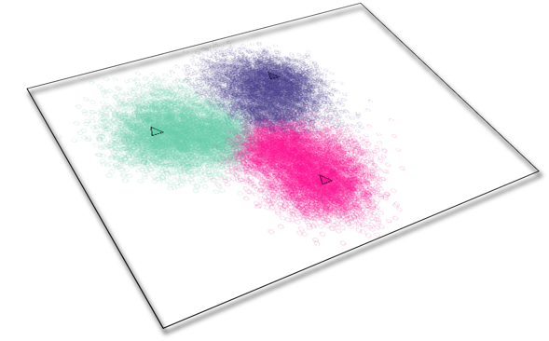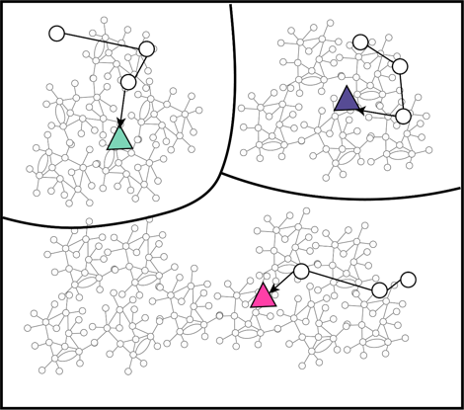

**Figure .** **Attractor Landscape. Attractor landscape including the associated attractors for the 2 conditions of interest: Cancerous (Ca) and Normal (Norm).**

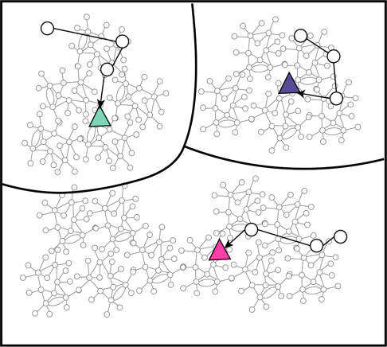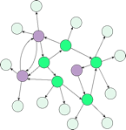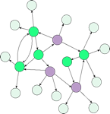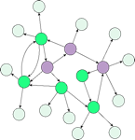

**Network nodes in basal state as normal**

**Norm0**

**Network nodes in basal state as cancerous**

**Network nodes in arbitrary basal state**

**Other0**

**Ca0**

In a mathematical model it is possible to find the attractor landscape – all the attractors of the model and the states that lead to them. Because the intracellular signaling network does not have dynamics, we can only estimate its attractor landscape. This requires an estimation of the networks dynamics, as is done by Signal Flow Analysis (SFA) (SOURCE). This algorithm developed by Cho et al. uses the topology of the network to predict how the activity of a molecule influences the activity of a molecule through a link. This is quantified by the sign of the interaction (activation or inhibition), the basal activity of the molecule receiving signal, the number of edges coming into the molecule receiving signal, and the number of edges leaving the signaling molecule. The algorithm can be solved to find the estimated steady state log activity of each network node for any basal condition. To approximate the attractor landscape, we initialized our network with 100,000 unique random initial conditions of 1, 0, and -1, and simulated the resulting attractors with SFA. The network was also initialized with basal conditions for each of the four MCF10A and four MDA-MB-231 RNA-seq replicates and their corresponding attractors were simulated.

*Identification of Phenotype Landscape with Unsupervised Clustering*

The resultant attractors need to be grouped into phenotypes based off of similar attractor values. This was accomplished through unsupervised k-means clustering with sklearn in python. Clustering was done with 10,000 initializations and several values of k. Sum of squares for the clusters produced from each k value was analyzed and the optimal k was chosen to separate the “normal” attractors simulated from the MCF10A basal conditions and the “cancerous” attractors simulated from the MDA-MB-231 attractors. The resultant clusters represent different cell phenotypes, not necessarily just cancerous and normal. This is the phenotype landscape of the signaling network.

*** Discuss what you clustered off of

*** DAC

**** Discuss challenges of interpreting SFA?

*** distance metric and algorithm for kmeans

**III. Identification of Putative Reversion Targets**

*Identification of the Feedback Vertex Set*

The feedback vertex (FVS) sets of the network were identified using our tool OCSANA+ in Cytoscape. The FVS contains nodes whose concerted perturbation can drive the state of the network to any biologically relevant attractor from an arbitrary initial state. There can be multiple FVSes of a network, but we are interested in the minimal FVSes (mFVSes). These are the minimal number of nodes whose removal from the network interrupts all of the feedback loops.

*In Silico Screenings*

To predict the effect of perturbations of the FVS nodes on the tumorigenic cell, we ran *in silico* screenings with SFA. The network was initialized with the basal state for MDA-MB-231. Up to 100,000 concerted perturbations of the FVS nodes (either activation, inhibition, or no change) were applied to the MDA-MB-231 basal states of the FVS nodes, and the resultant attractor was simulated with SFA. Instead of solving the algorithm for the steady state, the iterative method was used so that FVS nodes can be fixed to their basal values. At each time step, the FVS node values are overridden to represent the effect of permanent, as opposed to transient, perturbations on the network. *In silico* perturbations were also run on the FC set, which includes both the FVS nodes and the source nodes. The results of these screenings are termed perturbation attractors.

*Classification of In Silico Perturbation Attractors*

Attractors produced from *in silico* perturbations of the FVS set need to be classified as a phenotype for identification of putative reversion targets. To do so, the clustered attractor landscape is used as a training set for k-nearest neighbors classifier on the perturbation attractors. Perturbations whose attractors are classified in the “normal” cluster have triggered a shift away from the cancerous attractor and towards the normal basin of attraction, indicating they are putative reversion targets.

*** (What distance metric, how do we determine k)

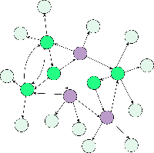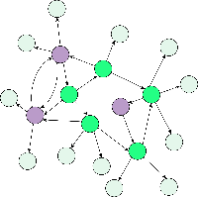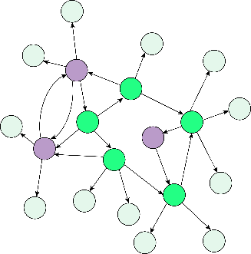

T0Normal

T0Cancer

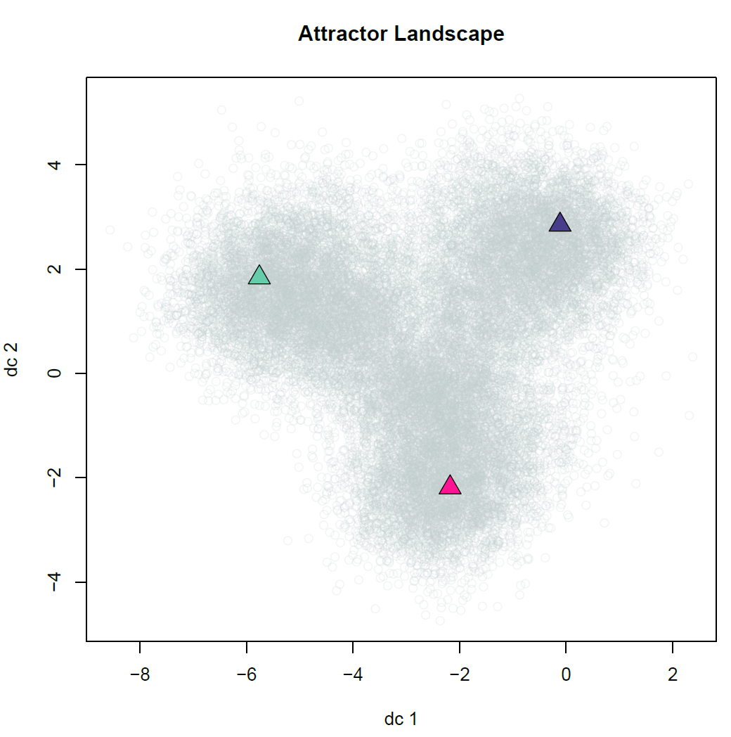

**Simulating network to**

**identify associated attractor**

**from each initial condition**

…

**Simulating network to**

**identify associated attractor**

**from initial condition**

**with FC nodes perturbed**

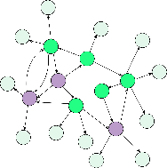

…

T0

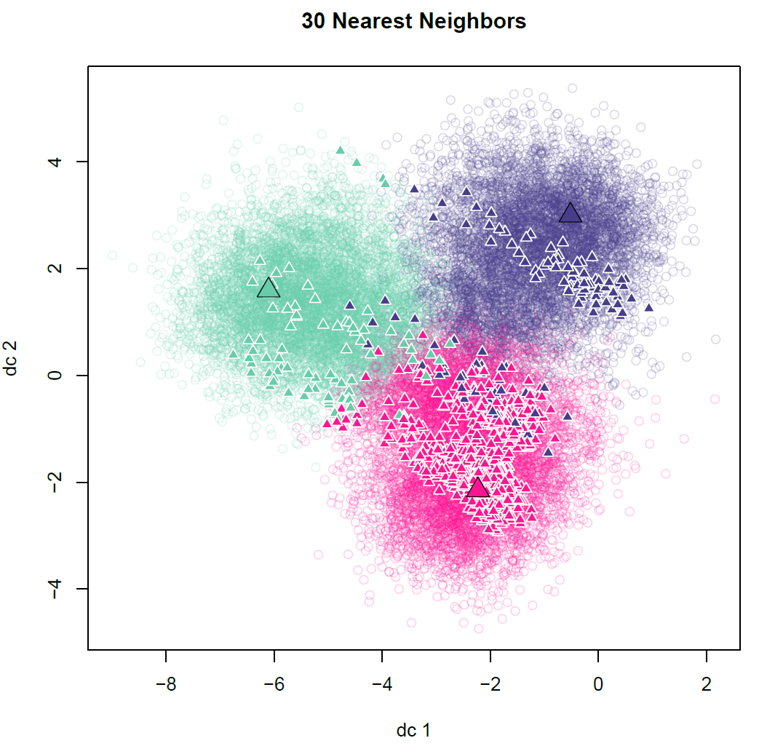

**Classified Attractors**

**(by K-Means)**

**Classify Newly Generated Attractor from**

**Perturbed FC (by K-Nearest-Neighbors)**

?

?

?

Norm0

Ca0



*Prioritization of Putative Reversion Targets*

The perturbations that result in attractors in the normal cluster need to be prioritized for experimental validation. This is done by quantifying how similar the MCF10A and the perturbation attractors are. The direction of activity change (DAC) between MCF10A and MDA-MB-231 attractors and the perturbation attractor and MDA-MB-231 attractor were calculated and grouped into three values: 1 for positive DACs, -1 for negative DACs, and 0 for zero DACs. The hamming distance between the DAC of MCF10A against MDA-MB-231 and the DAC of the perturbation attractor against MDA-MB-231 was calculated and perturbation attractors with smaller distances will be prioritized over larger ones. Additionally, the number of perturbations required to trigger a shift in phenotype will be considered because the MDA-MB-231 basal value of some FVS nodes may already be in the correct orientation and not need perturbation.

*** Mention Druggability

**IV. Reconstruction of Boolean Network**

*Training Static Network*

Phosphoproteomic data [24888630] and phosphoproteomic perturbation data [28915803, 29435015] for MDA-MB-231 was taken from ProteomeXchange under the identifiers PXD000948, PXD006430, and PXD003092. Additional perturbation data for MDA-MB-231 will be taken from EMBL-EBI under the accession number E-MTAB-1230 [28411283].

*Literature Curation*

*Majority Function*

**V. Attractor Landscape Of Boolean Network**

*Attractor Landscape Estimation*

BoolNet sat.echaustive

*Sammon Mapping/Clustering????*

**V. Testing Putative Reversion Targets from Signaling Network**

*See where Boolean attractors from these perturbations cluster*

*Examine RONs of Boolean attractors   
Pray for the best*

Reminders:

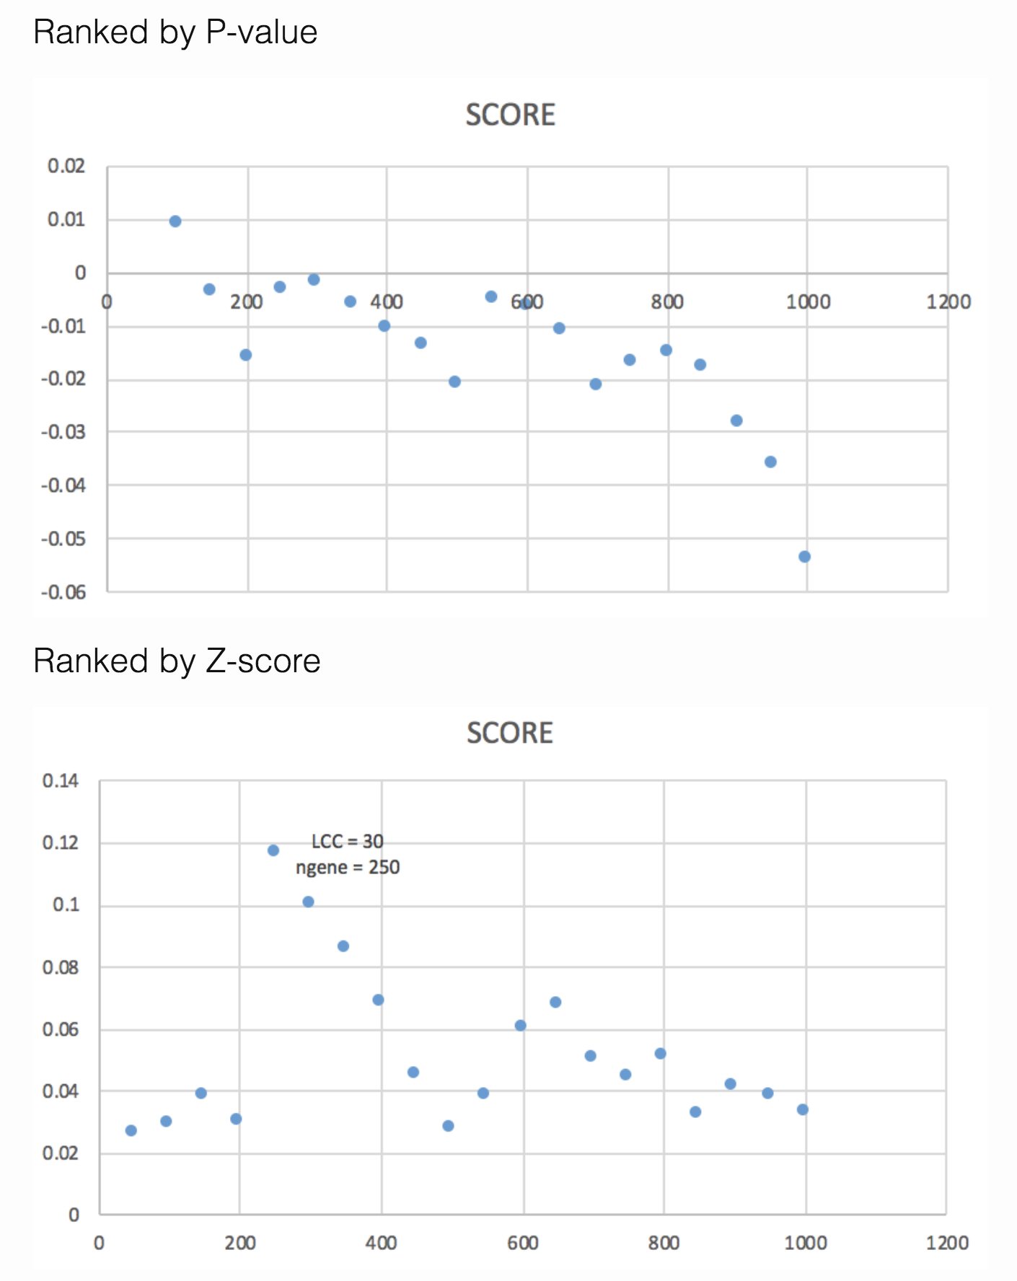

**Outline**

* Data collection/sources
* Construction of multi-omics network
  + Binom / funDEGs -
  + Transfac -
  + Transpath -
  + Ipa -
  + Rekinect -
  + Cosmic -
  + Vep -
  + Genexplain -
* Landscape Simulation
  + Approximation with SFA
  + 100,000 random inits
  + Unsupervised k-means clustering to associate phenotypes
  + Refer to SFA exploration
* Target identification
  + Structure based control
  + In silico perturbations
  + DAC
  + Knn classification